A key limitation of traditional SoVI formulations is the dependence on PCA with additive aggregation of factor scores, which can obscure substantively meaningful co-occurrence patterns among indicators. For example, a census tract may simultaneously exhibit high poverty and high per capita income. If these variables load in opposite directions with similar magnitudes across retained components, their contributions to the composite index can partially offset, reducing apparent vulnerability in the final score despite the tract’s structurally complex profile.
Cluster-based approaches (e.g., k-means) provide a different representation: tracts are assigned based on multivariate similarity, so variables are not collapsed into a single signed sum in the same way. This can preserve mixed socioeconomic signals and reveal interpretable tract types (e.g., transitional or internally heterogeneous neighborhoods) that are difficult to capture with a unidimensional index. Fuzzy clustering methods like Fuzzy C-Means can add further value by estimating graded membership across clusters, allowing identification of tracts that sit between vulnerability regimes rather than forcing hard assignment.
Both PCA-based indexing and clustering are dimension-reduction strategies, but they answer different questions: SoVI estimates position on a continuous latent vulnerability axis, whereas clustering identifies typologies of social-environmental structure. Accordingly, clustering may yield a more nuanced characterization of complex tract profiles in contexts where compensatory effects in additive indices are a concern.

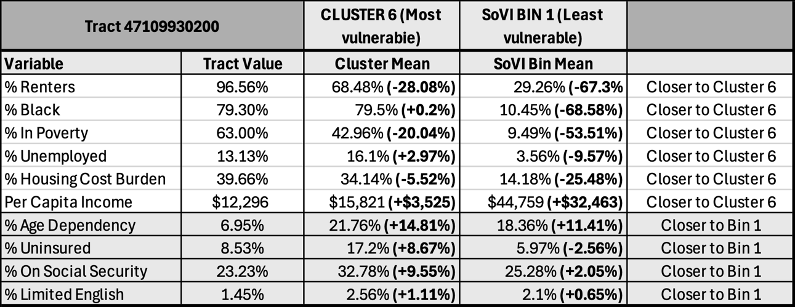
Table 1. Comparison of SoVI variable values for a census tract exhibiting a high degree of mismatch between cluster assignment and SoVI score.

We can see the obscuring effect of PCA in action by examining individual census tracts. Table 1 shows the values of a selection of SoVI variables for a census tract in downtown Memphis, Tennessee. This tract was assigned to Cluster 6, the most vulnerable cluster, by the k-means algorithm. However, this tract was also in the bottom 15% of SoVI scores (Bin 1), indicating that it should be one of the least vulnerable tracts. By comparing the vulnerability characteristics of the tract to the mean values of tracts in Cluster 6 and Bin 1, we can see that the tract more closely aligns with the high-vulnerability Cluster 6. In most cases, the tract’s value is close to the mean value for Cluster 6 (79.3% Black compared to 79.5% on average; $12,296 per capita income compared to $15,821 on average), and in some cases, considerably higher (96.6% renters compared to 68.5% on average). If this specific tract appears to more closely match a high-vulnerability cluster, then why is its SoVI score so low? To understand this phenomenon, we need to look at the original PCA factor loadings, from which both the SoVI scores and the k-means clusters were built, in Figure 1.
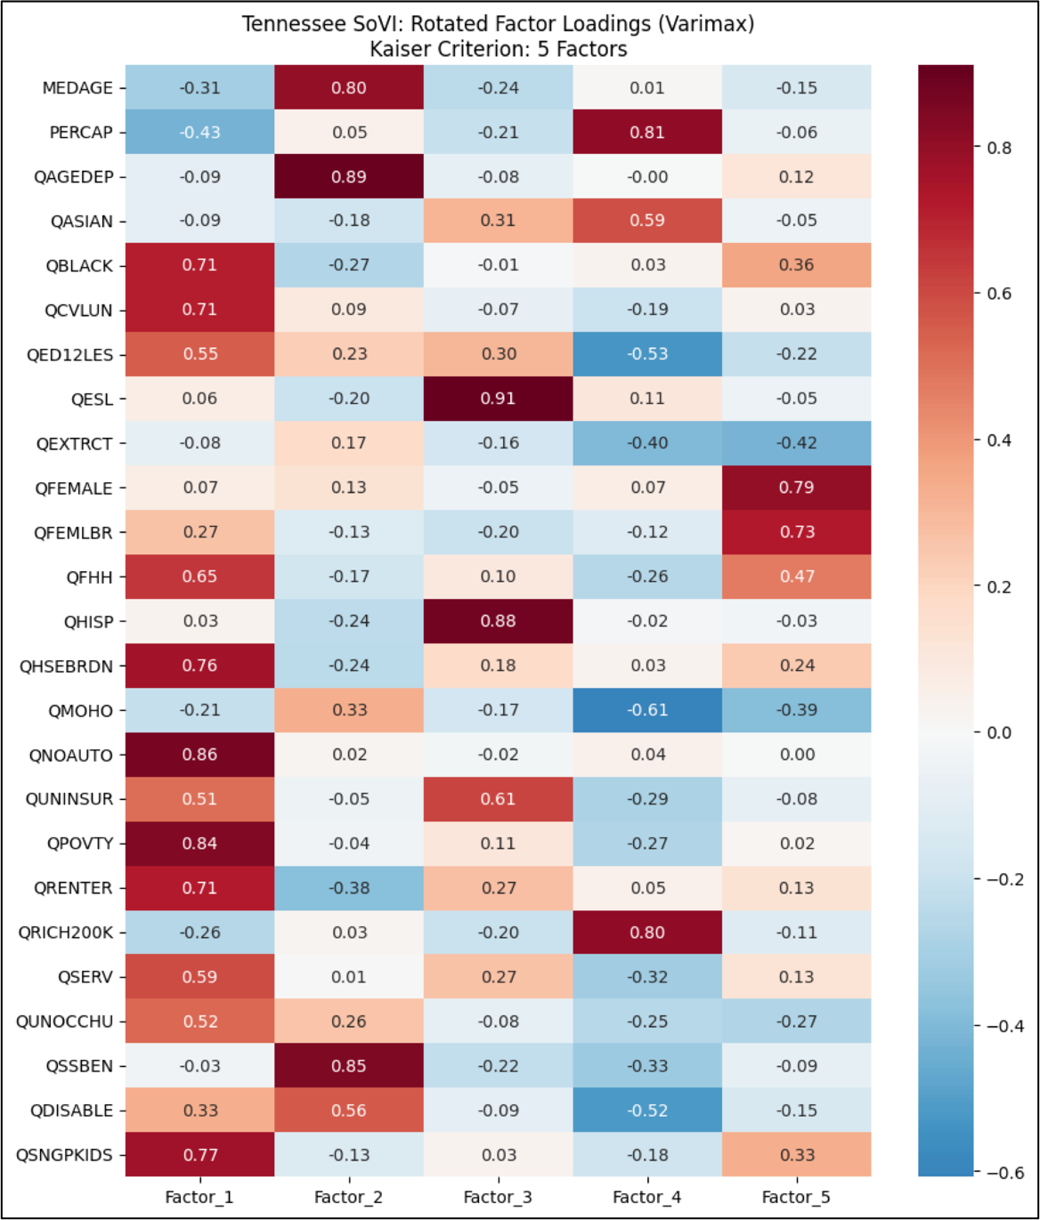
Figure 1. Rotated component matrix for PCA performed on Tennessee census tracts using SoVI variable data from 2015-2019 American Community Survey estimates. Factor 4 was inverted during score calculation, as it had positive loadings for indicators of wealth.

Evaluating the factor loadings reveals the obscuring effect and clarifies the extreme discrepancy in apparent vulnerability level for the tract. The tract’s individual factor scores were, in order from Factor 1 to 5: 3.84, -2.75, -1.96, -0.14 (inverted to 0.14), and -2.82. Summing these scores together yields an overall SoVI score of -3.55, indicating very low vulnerability. Even though the tract scored very highly on Factor 1, which contains most of the high-vulnerability characteristics, negative scores in the other factors negated its overall influence on the score. This is especially concerning considering that Factor 1 accounted for roughly 30% of the variance in PCA, while Factors 2 and 3 accounted for 19% and 10% respectively. Factors 4 and 5 accounted for only 5% of the variance, yet the tract’s loading of -2.82 in Factor 5 was a major contributor to its overall low SoVI score.
One could argue that the SoVI score is accurate, and that the vulnerability revealed by the variables with high loadings in Factor 1 is effectively mitigated by the low loadings in the other factors. But, in looking at this tract’s mean values, does that seem to be true? Do the low uninsurance and limited English ability rates actually mitigate a rental rate nearing 100% and a poverty rate of 63%? Clustering algorithms allow us to avoid difficult questions like these by categorizing tracts based on similarities in their equally weighted characteristics. In this case, the census tract in question is more closely aligned with other high-vulnerability tracts and was thus put into a high-vulnerability cluster. Even though none of the SoVI variables are intended to be unevenly weighted in the creation of SoVI scores, the PCA process itself creates conflicts between the variables’ relative influences that clustering does not.
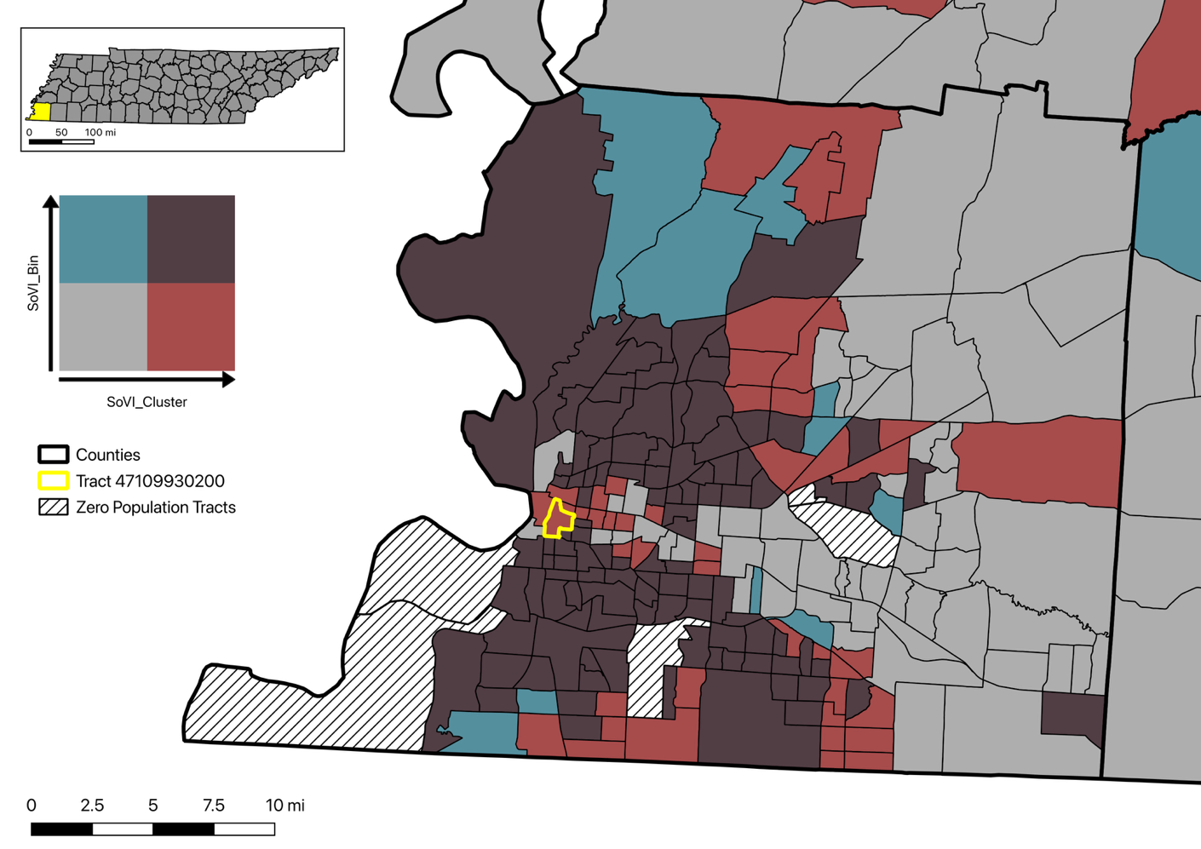
Figure 2. Bivariate map of cluster assignment and SoVI scores (binned to match number of clusters) for Shelby County, Tennessee. Red and blue tracts show where SoVI scores underestimate or overestimate vulnerability respectively. Brown and gray tracts show where cluster assignment and SoVI score are roughly equal. The tract discussed in the section above is outlined in yellow.

